

Ankara Yıldırım Beyazıt University

Department of Computer Engineering

CENG 201 – Object Oriented Programming  
Course Project

GROUP 7: Expense Tracker Application

Analysis Report

Furkan İÇTÜZER,   
Serhat ERDOĞAN,

Selim ÇENTELİ,

Sümeyye Feyza YEMENOĞLU,

Saidahmad USMANALIEV

**Instructor**: Muhammed Abdullah Bülbül

**Teaching Assistant:** Elif Şanlıalp, Yusuf Şevki Günaydın

**Date:** 09/12/2024

**Table of Contents**

1. Introduction 2

2. Class Responsibility Collaboration (CRC) Cards 2

3. UML Class Diagram 8

4. Conclusion 8

# Introduction

Goal of this project is creating an expense tracker application. By the help of the application, users will be able to set budgets, keep track of expenses and categorize them, generate reports about the expences, be reminded by notifications about their budgets and near miss payments. In this report, Class Responsibility Collaboration (CRC) cards are introduced and the final design of the classes are shown.

# Class Responsibility Collaboration (CRC) Cards

**metin, ekran görüntüsü, yazı tipi, sayı, numara içeren bir resim

Açıklama otomatik olarak oluşturuldu**

**Figure 2.1. ExpenseManager Class**

**metin, ekran görüntüsü, yazı tipi, sayı, numara içeren bir resim

Açıklama otomatik olarak oluşturuldu**

**Figure 2.2. User Class**

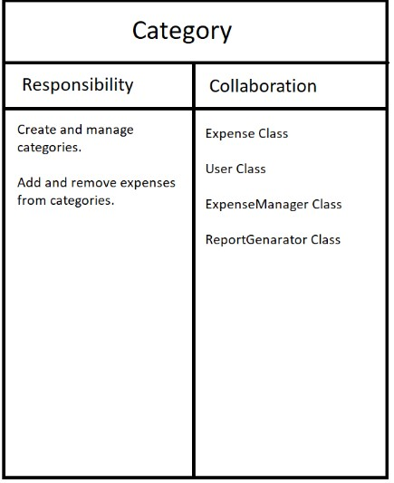

**Figure 2.3. Category Class**

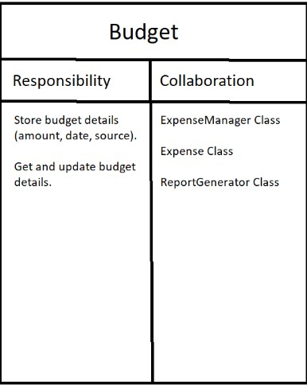

**Figure 2.4. Budget Class**

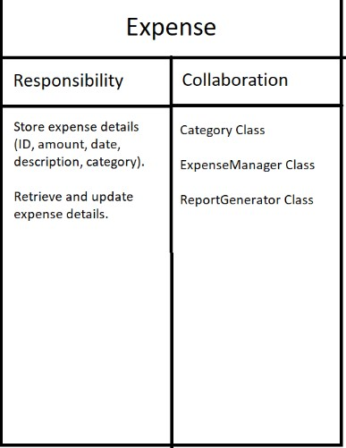

**Figure 2.5. Expense Class**

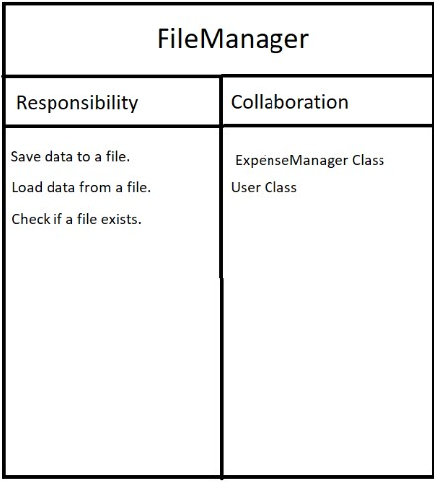

**Figure 2.6. FileManager Class**

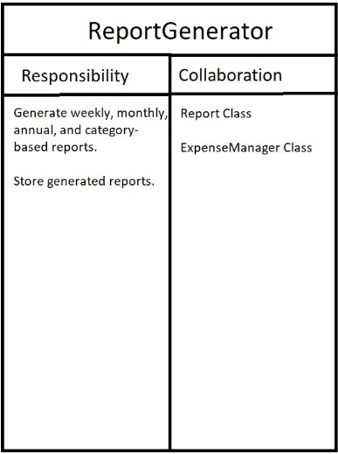

**Figure2. 7. ReportGenerator Class**

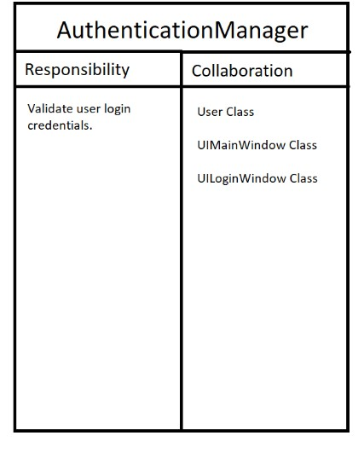

**Figure2. 8. AuthenticationManager Class**

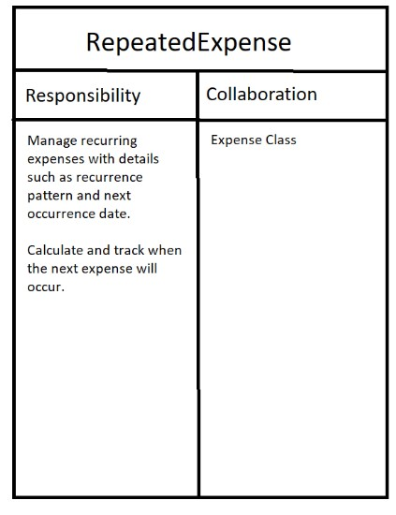

**Figure2. 9. RepeatedExpense Class**

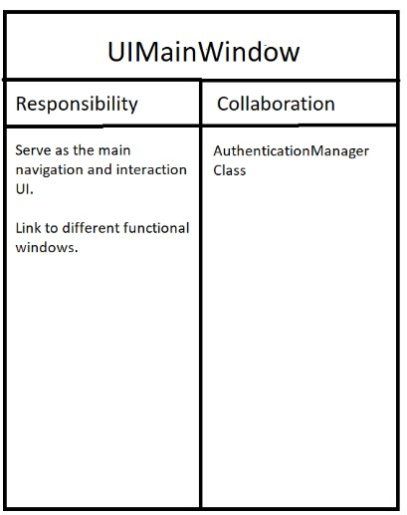

**Figure2. 10. UIMainWindow Class**

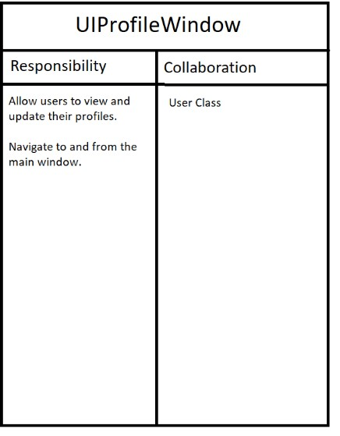

**Figure2. 11. UIProfileWindow Class**

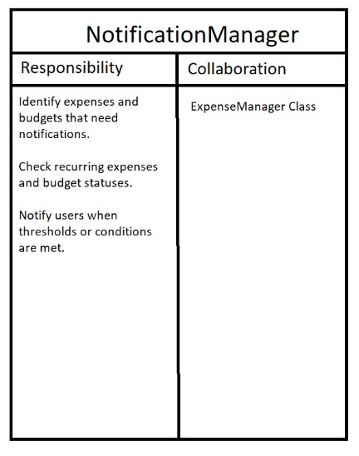

**Figure2. 12. NotificationManager Class**

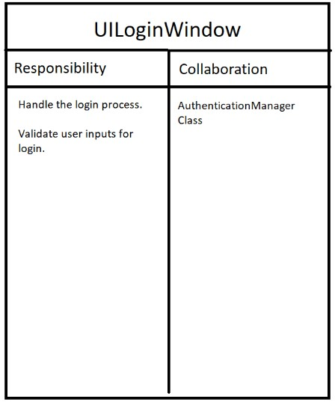

**Figure2. 13. UILoginWindow Class**

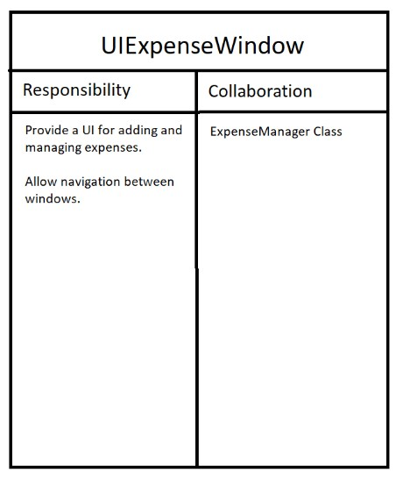

**Figure2. 14. UIExpenseWindow Class**

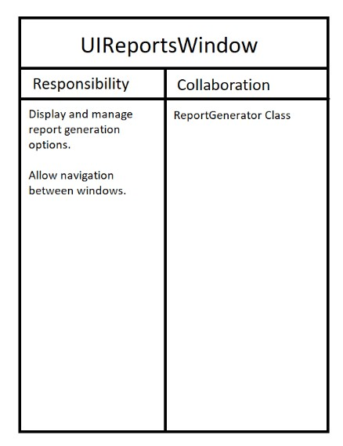

**Figure2. 15. UIReportsWindow Class**

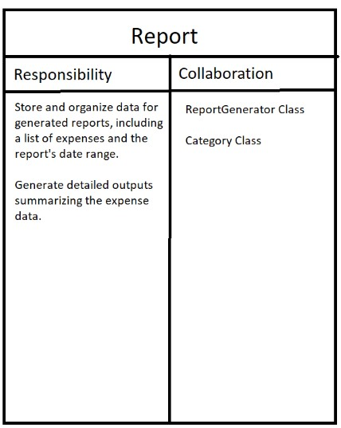

**Figure2. 16. Report Class**

# UML Class Diagram



# Conclusion

In this analysis report, Class Responsibility Collaboration (CRC) cards are demonstrated and the final design of UML class diagram, including all attributes and the functions, is determined.

Innovations and the updates to the previous design were contributed by Furkan İÇTÜZER, Serhat ERDOĞAN, Selim ÇENTELİ, Sümeyye Feyza YEMENOĞLU, Saidahmad USMANALIEV. Class Responsibility Collaboration (CRC) cards are visualized by Serhat ERDOĞAN. The UML diagram was updated by Furkan İÇTÜZER, Serhat ERDOĞAN and Selim ÇENTELİ. Report writing process was held by Furkan İÇTÜZER and Sümeyye Feyza YEMENOĞLU.